Adapted from http://www.animalfactguide.com/animal-facts/emperor-penguin/

On land, with an egg on your feet:
Emperor penguin dads keep the egg on their feet while the egg incubates.
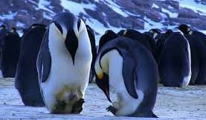
They cover the egg with an extra piece of skin and feathers called a brood pouch.

The dads stay close together, really close together in what’s called a huddle.
They move together, trading places from the middle of the huddle to the outside and back again so that no one penguin gets too cold.
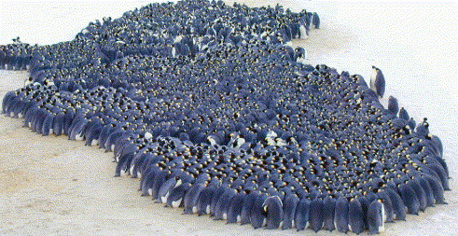
Now, THAT’S called cooperation!

The emperor penguin egg and chick:
